**What is Climate Change?**

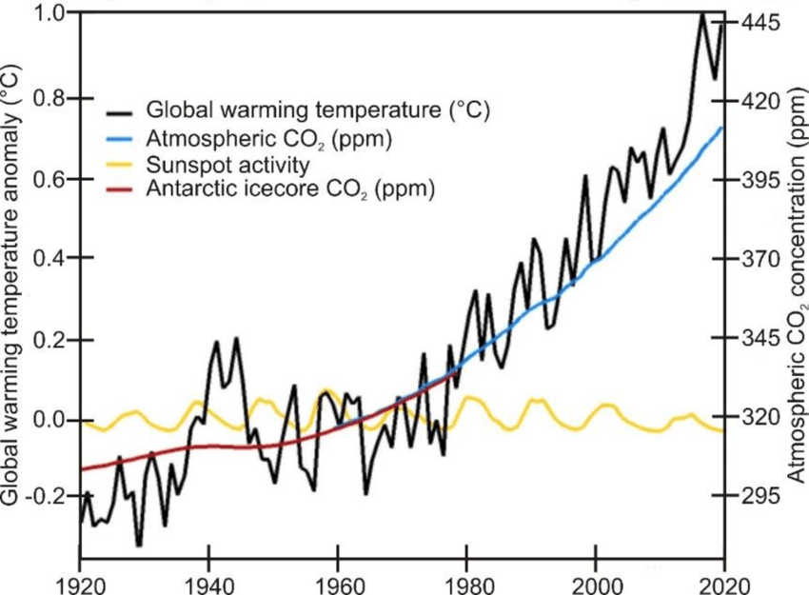Climate change refers to big shifts in the weather that happen over a long time, affecting things like temperature, wind patterns, and rainfall in different places, from neighborhoods to entire continents. These changes can last for decades or even millions of years. While nature plays a role in these shifts, scientists agree that human activities, like burning fossil fuels and industrial processes, are the main drivers of the current climate changes we're experiencing.

Looking at the graph, we can see a sudden increase in carbon emissions and concentrations, which basically means there's more of these gases in the air. This spike lines up with a time when people were ramping up industrialization and using a lot more fossil fuels. At the same time, the graph shows that global temperatures started to climb too, showing how closely linked our actions are to the changing climate. It's like pressing a button and seeing the effects right away. So, it's really important for us to find ways to reduce our greenhouse gas emissions to help slow down these changes and protect our planet for the future.

This figure illustrates the interaction between human generated carbon emissions, atmospheric carbon dioxide content and average global temperatures

**WHAT IS GREENHOUS EFFECT**

The greenhouse effect is like a cozy blanket wrapped around the earth, helping to keep us warm. Here's how it works: when sunlight reaches the earth's surface, some of it gets absorbed, warming up the ground. Then, the warmed-up earth releases some of that heat energy as thermal infrared radiation. But instead of escaping into space, this radiation gets trapped by certain gases in our atmosphere, like water vapor, carbon dioxide, methane, and nitrous oxide. These gases act like a giant blanket, bouncing the heat back down to earth and keeping our planet at a comfy average temperature of about 14°c.

Normally, this natural blanket is a good thing—it keeps us from freezing in a chilly -19°c world! But here's the catch: humans are adding extra layers to this blanket by pumping more greenhouse gases into the atmosphere through things like burning fossil fuels and deforestation. As a result, our planet is getting too warm, leading to climate changes that can cause all sorts of problems. So, while we definitely need some greenhouse gases to stay cozy, we need to be careful not to overdo it and make things too toasty for our own good.

