**How do humans contribute to climate change?**

So, how do we humans make climate change worse? Well, it's mostly because of what we do with stuff like gas, coal, and oil. When we burn these fossil fuels for things like driving cars and making electricity, they let out gases like carbon dioxide, methane, and nitrous oxide. These gases act like a thick blanket around Earth, trapping heat and making our planet warmer. And get this: since the 1900s, we've pumped out so much carbon dioxide that there's now 32 percent more of it in the air!

But it's not just cars and factories causing the problem. Even things like throwing away trash and certain industrial activities can release these gases. Every time we use energy—like turning on lights or using electronics—we're adding to the greenhouse gas mess. But hey, here's the good news: we can all do things to help out! Simple stuff like using less energy, recycling, and supporting cleaner ways to power our world can make a big difference in cutting down on these gases. So, what can you do to pitch in and help fight climate change?

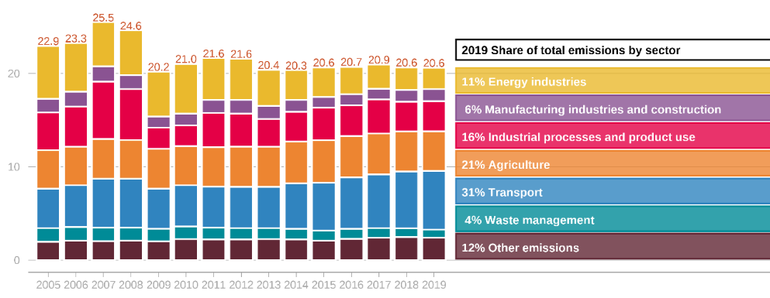  
Figure 1. Total GHG emissions by sector in Lithuania

Study the graph. Think about the human activities that produce greenhouse gases (GHG) in each sector. Which sector produces the most GHG? How can we reduce GHG emissions in each sector? What do you think this graph will look like in 30 years?