**Regional Impact of Climate Change**

Alright, let's talk about how climate change could shake things up right here in the Lithuania. Picture this: winters might not feel as chilly, summers could scorch even hotter, and we might see more crazy weather like intense storms. Furthermore, in Lithuania, it seems like the Baltic Sea coast region is in a tough spot when it comes to climate change. The coast, along with its ecosystems and the people who live there, are feeling the effect of rising sea levels, fierce storm winds, warmer waters in the sea and Curonian Lagoon, and changes in how salty the water is. Experts say these changes could really mess with our homes, nature, and the way we live. But hey, it's not all bad news! Sometimes, a warmer climate might bring some perks and chances for our community. Check out some examples of how climate change could influence people, both good and bad.

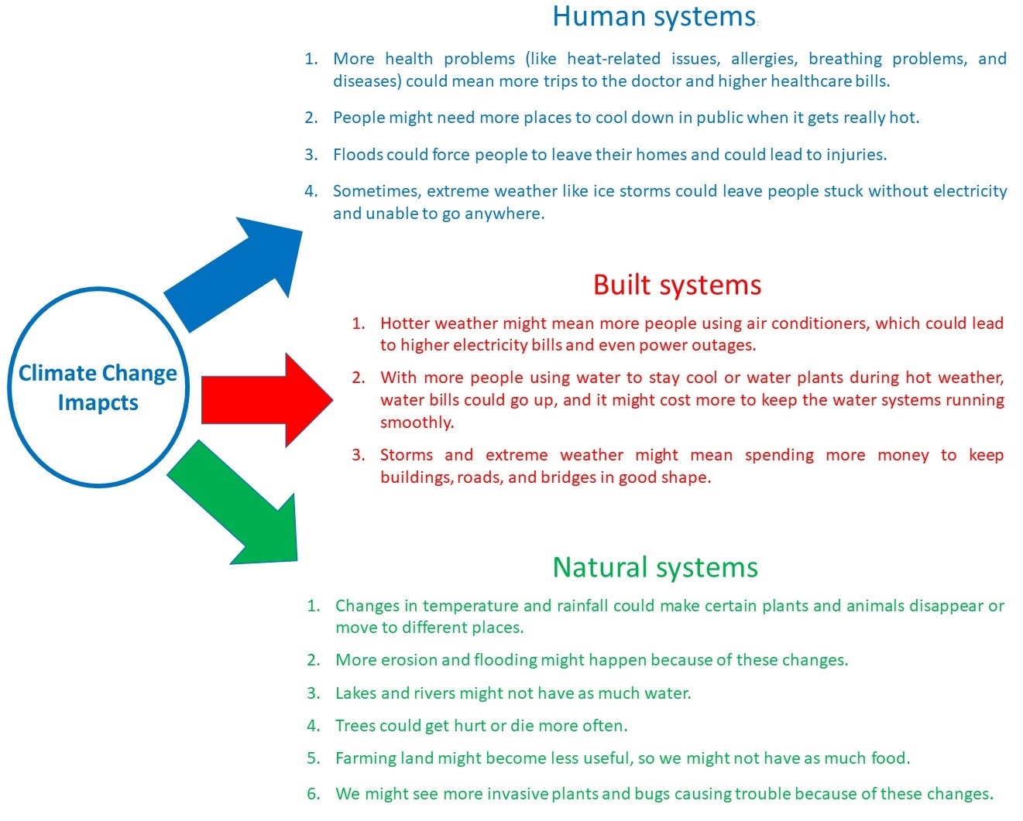

*“****Climate change is the greatest threat to our existence****in our short history on this planet. Nobody’s going to buy their way out of its effects.”*

**Mark Ruffalo**